ShareFile Master Guide

Contents
A1. ShareFile Entitlement 2
A2. Installing Citrix Files (ShareFile) 4
A3. ShareFile Setup and Use 6
A3b. ShareFile Status Page 6
A4. Using the ShareFile Plugin for Outlook 7
A5. Logging into ShareFile from Outlook 9
A6. Outlook What is the maximum message size 11
A7. Installing with Portal manager 11
A8. ShareFile attaching all files without user input 13
A9. ShareFile Users Need H Drive 15
A10. ShareFile - Copy files from mobile device to DH computer 15
A11. Access ShareFile from File Explorer 20
A12. ShareFile Login Error 24
A13. How to manage people in ShareFile 25
A14. ShareFile gives an "edit access error" when creating file links 27
A15. ShareFile connecting to I: Drive 29

A1. ShareFile Entitlement
Keywords – Granting ShareFile Access with Entitlement, Entitlement ShareFile, IAM ShareFile entitlement, Share file,
Adding and removing entitlements within IAM profile of user (Example here is adding pdfElement)

To Add an Entitlement:
Step 1 - In user’s profile, click on Add/Remove Entitlement(s)
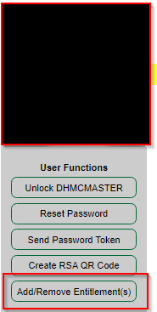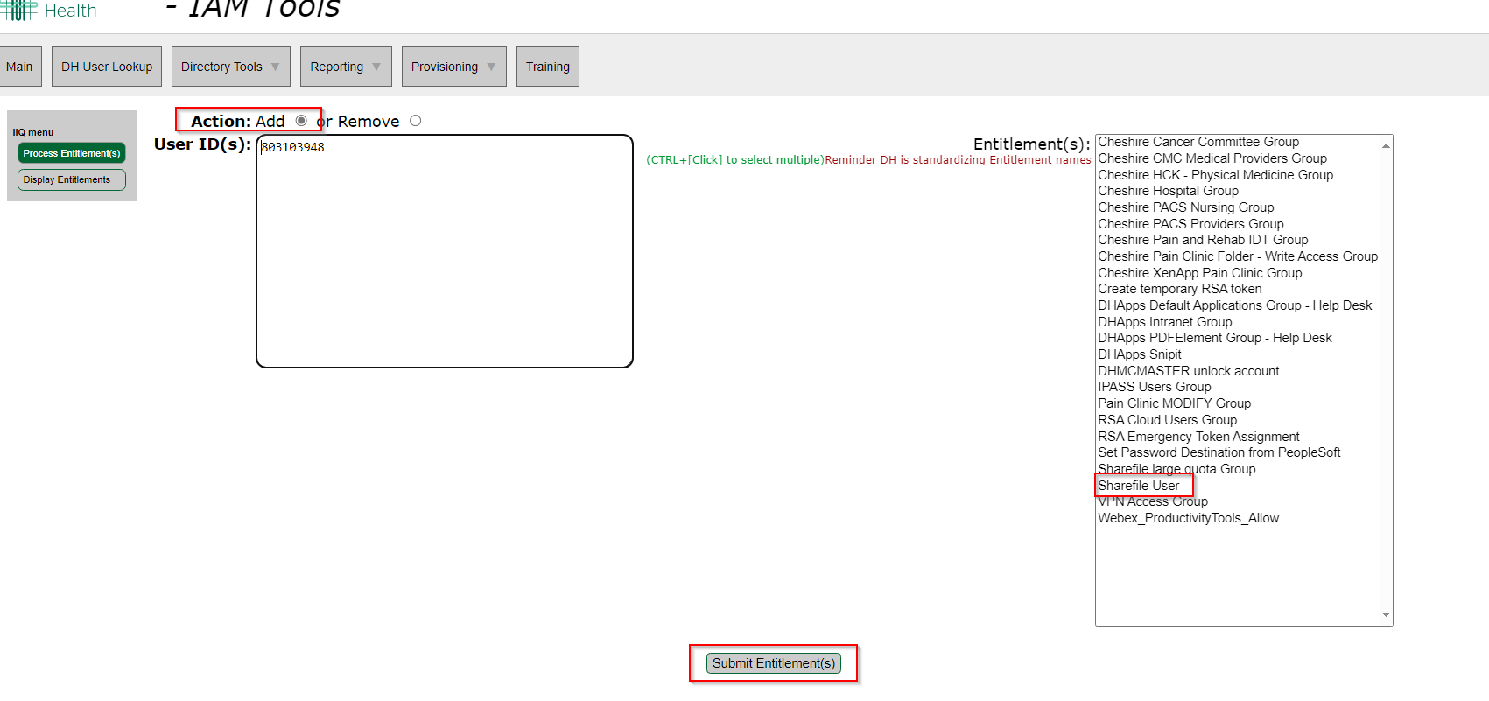

Step 2 - Select whichever entitlement that is to be given to user.
There will be a message of processing, then should see message indicating that the entitlement [whatever entitlement being given] was added to “username”.
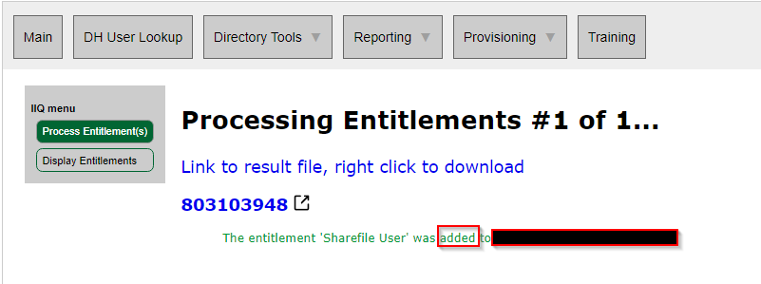
Note: Some Entitlements, such as ShareFile, take up to an hour to be active.. Sync happens at the top of the hour.

To Remove an Entitlement:
Select remove button rather than add in step 3 above.

Below is the canned response for After ShareFile entitlement is given:
Please be sure to edit the times in italics
I have add you to the ShareFile group. This will take effect after Hour am/pm today. Please log off of the computer and back on at Hour:05 am/pm for this to take effect. Below are links to information about the use of ShareFile:

http://one.hitchcock.org/intranet/departments/help-desk-user-support/services-provided/sharefile
http://one.hitchcock.org/intranet/departments/help-desk-user-support/services-provided/sharefile/share-a-file-using-email

Have a great day!

Primary CI : depends on entitlement
Service Catalog values can use Help Desk > Access > Submit Request

Tier 1: IS-Support - Help Desk
Tier 2: IS - Support – Access and Accounts or task Windows
Tier 3: Depends on entitlement

Return to table of Content
-------------------------------------------------------------------------------------------------------------

A2. Installing Citrix Files (ShareFile)
Citrix files install, ShareFile Install, Outlook ShareFile install, Outlook Citrix files install, ShareFile, Outlook CitrixFiles
Issue

The user does not have the Citrix Files (ShareFile) buttons / add-in available in Outlook.

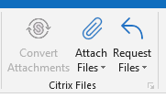

Solution

Citrix Files (ShareFile) can be added to the user's computer either through the Ivanti Portal Manager or pushed to the user's machine from the Ivanti Web Console (KA 3920).

Note the user must be a "ShareFile" user in IAM tools for this to work: 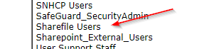

See ShareFile Entitlement if the user does not have this entitlement.

Portal Manager:

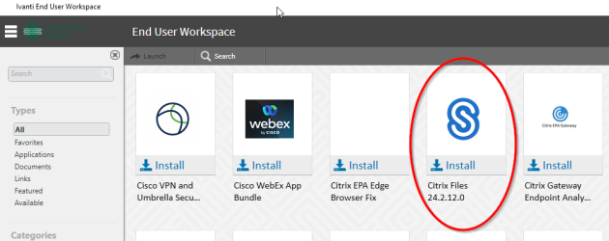

Ivanti Web Console:

CI = N/A

Service Catalog Values = Application Support > How Do I? > General Request

Escalation Tree:
Tier 1: IS - Support - Help Desk
Tier 2: IS - Support - LEB Software (Or Regional Support)
Tier 3: N/A

Return to table of Content
-------------------------------------------------------------------------------------------------------------

A3. ShareFile Setup and Use
Keywords – CitrixFiles setup Citrix files use, ShareFile Use, Share File, Citrix Files, Setup ShareFIle, Setup Citrix files
Secure file transfer Ver 2

Introduction
Use ShareFile to exchange data files when email is impractical
- • Files content is protected health information (PHI)
- • File is too big for email
- • Confidential information for D-H partners and vendors

ShareFile provides increased security compared to compressed files (.zip, .tar, .7z, etc.), even with their password protection. In addition, ShareFile manages and shares entire folders, sends notification when files are accessed, and provides controls to limit or allow file access.
Get Started
To get started with ShareFile contact Desktop Support by phone (5-2222) or email (is-support@hitchcock.org). A technician will configure your account to use the ShareFile server.
Connect
Connect to ShareFile using your web browser https://dh.sharefile.com.
When prompted use Company Employee Sign In. Click Sign In.
Provide you D-HH account name and password at the Dartmouth-Hitchcock log on site.
ShareFile opens to your dashboard, a view that puts the most used features just a click away.
Learn about ShareFile
In the bottom left quadrant of your ShareFile dashboard there is a section reserved for video tutorials. Pick the Getting Started category, where there are buttons to launch these short videos, plus to more in the Basic category. Each video about 2 ½ minutes long, and they clearly explain how to use ShareFile. English captioning is available for hearing disabled or quiet offices.

A3b. ShareFile Status Page
Keywords – Status Page, ShareFile Status, Subscribe, not working, ShareFile Website
ShareFile has a status page so if someone calls and says "ShareFile isn't working" it may be reported on this website: https://status.sharefile.com/
You can also subscribe to this page via e-mail.

Return to table of Content

A4. Using the ShareFile Plugin for Outlook
Keywords – Outlook Plugin, Outlook Plug in, Outlook ShareFile Plugin, ShareFile Plugin use
After your account is configured for ShareFile and you are familiar with how it works, you can install the ShareFile Plugin for Outlook.
Getting started
Figure 1: ShareFile Outlook Plug-in is installed. Click to view option settings.
Open Outlook. The Citrix Files for Outlook logo will be displayed on the far right on the Outlook tool bar. If the logo displays "Log In", click on the logo to log in. ShareFile Secure file transfer Ver 2
KA 3883 Page 2 of 2 1/16/2023
Other functionality will be available when you compose or read a message.
Figure 2: Sharefile buttons in a new message window.

Save an email attachment directly to Citrix with a few clicks.
Note: Sharefile automatically converts large attachments to Sharefile uploads. Adjust the size limit in Sharefile settings.
1. In Outlook, click New Email.
2. A new message window opens.
  - 3. Click Attach Files button. a. From PC to select a file on your computer or network drive.
  - b. From Citrix to select a file previously uploaded to Sharefiles

  - 4. Sharefile adds Citrix Attachments notice to your email message.
  - 5. You may continue composing the message body above or below the notice.
  - 6. Click Send

Request that someone send files to you via Sharefile, even if they don’t have a Sharefile account. This is useful for exchanging files with people working outside D-HH.
1. In Outlook, click New Email.
2. A new message window opens.
3. Click Request Files button.
4. Sharefile adds text ‘Click here to upload files’ with a link to dh.sharefile.com.
5. You may continue composing the message body above or below the notice. Instruct the recipient to click the link and upload the files you are requesting.
6. Click Send

Drag files into your message, then convert them to Sharefile uploads
1. In Outlook, click New Email.
2. A new message window opens.
3. Open a file explorer window
  - 4. Drag your files into the Outlook Message window a. Files larger than 5MB are automatically converted to Sharefile uploads

  - 5. Click Convert Attachments button
  - 6. Sharefile adds Citrix Attachments notice to your email message.
  - 7. You may continue composing the message body above or below the notice.
  - 8. Click Send

This content is also in https://go.d-h.org/qngned

Return to table of Content
-------------------------------------------------------------------------------------------------------------

A5. Logging into ShareFile from Outlook
Keywords – Outlook ShareFile login, Outlook Citrix files login, ShareFile login, Citrix files Login
When it is necessary to log into ShareFile from Outlook the following are the steps:
Confirm that the user is in the ShareFile Users group in IAM: (access can be granted on request)
Remember that this updates at the top of every hour so access is not immediate. The user will need to log off and back on after the top of the hour that you add them to the group!
After the log off and back on, have them open Outlook
They will be prompted to log onto ShareFile or will need to click the icon on the Outlook Toolbar:
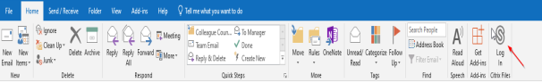
They will then get this screen: They should enter dh in the Subdomain box
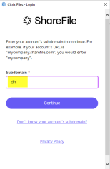
Then press Continue: Next they should click on Sign in with my company credentials
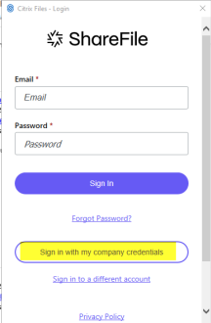
They will then see a Citrix login screen: Enter Window Username (not email address) and Password
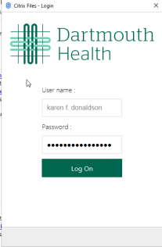
Click Log on and the icon on to turns Blue:
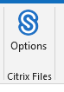
Helpful links:
http://one.hitchcock.org/intranet/departments/help-desk-user-support/services-provided/sharefile
http://one.hitchcock.org/intranet/departments/help-desk-user-support/services-provided/sharefile/share-a-file-using-email
CI = ShareFile
Service Catalog Values = Application Support>How Do I > General Request
Escalation Tree:
Tier 1: IS - Support - Help Desk
Tier 2: IS - Support - LEB Software (Or Regional Support)
Tier 3: N/A
Return to table of Content
-------------------------------------------------------------------------------------------------------------

A6. Outlook What is the maximum message size
Keywords – Sharefile for large messages, Outlook Maximum, Maximum size message
The message size for Outlook is 40 mb, internal and external outgoing messages. Also applies to Secure Mail.

For files over 40 MB use the ShareFile application

15MB for inbound messages composed by non-DH users.
ShareFile can also be used for receiving oversized messages from external senders.

Primary CI set to Exchange

Service Catalog values can use Help Desk > E-Mail/Calendaring > Submit Request

Tier 1: IS - Support - Help Desk
Tier 2: N/A
Tier 3: N/A

Return to table of Content
-------------------------------------------------------------------------------------------------------------

A7. Installing with Portal manager
Keywords – ShareFile install, Citrix files install, Citrixfiles install, ShareFile Portal manager, Share file portal manager, Citrixfiles Portal manager, Citrix files portal manager
1. Single click computer Windows Start menu in the bottom left corner and look for the Ivanti Management folder
OR
2. Type "portal" in the start menu like so:
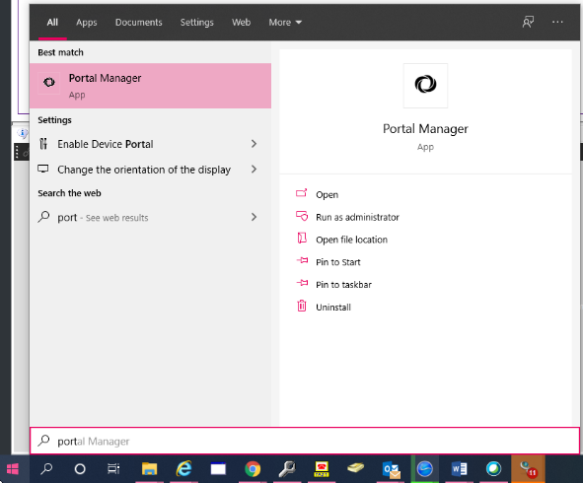
3. Open portal manager
4. Click install on the application you would like to install
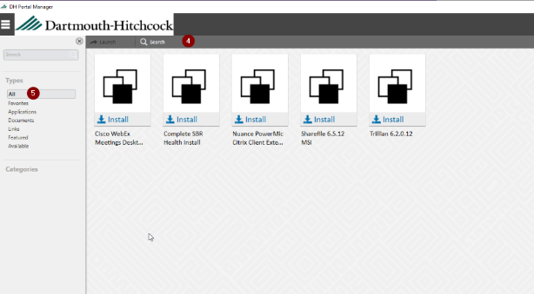

Options to launch the Portal Manager
- Selecting Portal Manager from the Start Manu
- Searching Portal Manager in the Search
- Launching the Program Directly form the file folder
  - C:\Program Files (x86)\Ivanti\EPM Agent\SWD\LANDeskPortalManager.exe
  - However if you run this program from the folder, it will run silently in the background.
- Command Line
  - ""C:\Program Files (x86)\Ivanti\EPM Agent\SWD\LANDeskPortalManager.exe" /showui=true
    - You can copy this command to run the install.
      - If you want it to run silent, remove the /showui=true

If the desired program does not install:

- Check that the time on the user's computer is in sync with DH computers.
  - If the time is not in sync with DH computers, follow KA 4996.
- Try to remove the old version of the program from the computer first and then install it with Ivanti Portal Manager.
- Try to push the software using Ivanti Web Management.

CI = Ivanti LANDesk

Service Catalog Values = Application Support > Maintenance > General Request

Escalation Tree:
Tier 1: IS - Support - Help Desk
Tier 2: IS - Support - LEB Software (Or Regional Support)
Tier 3: N/A

Return to table of Content
-------------------------------------------------------------------------------------------------------------

A8. ShareFile attaching all files without user input
Keywords – Sharefile automatically attaching files,
Navigate to options on the main inbox bar:
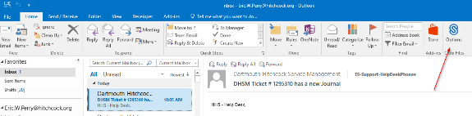
Edit general settings:

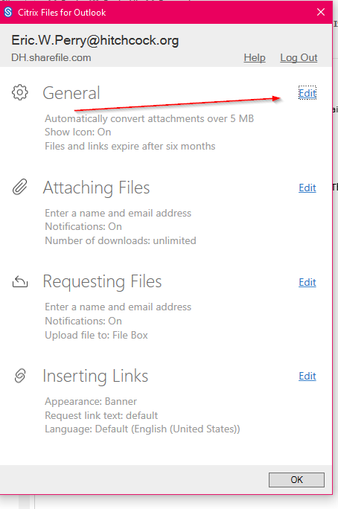

Adjust the following settings accordingly:
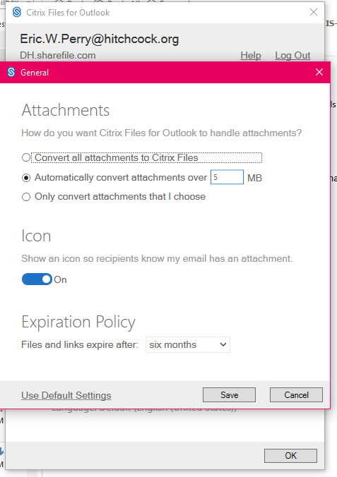

CI = Citrix ShareFile

Service Catalog Values = Help Desk > Software > Submit Incident

Escalation Tree:
Tier 1: IS - Support - Help Desk
Tier 2: Windows Admin
Tier 3: N/A

Return to table of Content
-------------------------------------------------------------------------------------------------------------

A9. ShareFile Users Need H Drive
Keywords – ShareFile H drive, H drive for ShareFile
Sharefile requires an H drive in order to be used. Submit request on behalf of the individual to IAM Accounts.

CI = Citrix Files (ShareFile)
Service Catalog Values = Help Desk > Access/Permission > Submit Request
Escalation Tree:
Tier 1: IS - Support - Help Desk
Tier 2: IS - IAM - Accounts and Access
Tier 3: N/A

Return to table of Content
-------------------------------------------------------------------------------------------------------------

A10. ShareFile - Copy files from mobile device to DH computer
Keywords – Pictures, Files, Video, Sharefile for file copy, move files
Problem
User wants to copy pictures, video, or other large files from their mobile device, save the files to their DH computer, and share the file using ShareFile.
Things to keep in mind
On mobile devices Secure Hub or Citrix workspaces which will not allow access to data stored on the user’s device. This is per DH security policy.
Note: The sharefile mobile app does not allow user to upload a photo or other document from the phone directly into sharefile
Definitions
ShareFile is a platform for securely uploading, storing, and sharing all kinds of files. It is appropriate for PHI, PII, and confidential business information. You can share files and folders, even allow other people to upload files, whether they are inside or outside the DH network.
[Source: Sharefile or https://one.hitchcock.org/intranet/departments/help-desk-user-support/services-provided/sharefile ]
Cause
An example of this usage would be when taking a photo of an error or important information with your phone. This information then needs to be shared or passed along for troubleshooting a problem or expediting a procedure.
An example situation is when a department needs to be recertified by an outside provider and the department needs to share a video of department set up. In this case the user takes a video of the department configuration with their mobile device and will share the video with others.

Troubleshooting
Does the user have the “sharefile user” entitlement in their IAM profile? Add entitlement if needed.
Does user know how to use sharefile? Provide link in DH Intranet pages at Sharefile.
Lead questions for the user
Is this an Android phone or ipad or iphone?
Do you have a browser such as Google Chrome or Safari on your device?
Have you used sharefile before?
Solution

The following are directions for using sharefile to transfer documents or photos to your DH sharefile location:

These are general instructions that could be used on an iOS (iPhone/iPad) or Android system.
1 - On the user’s phone, open a browser and enter the sharefile url, ie. ShareFile (dh.sharefile.com).
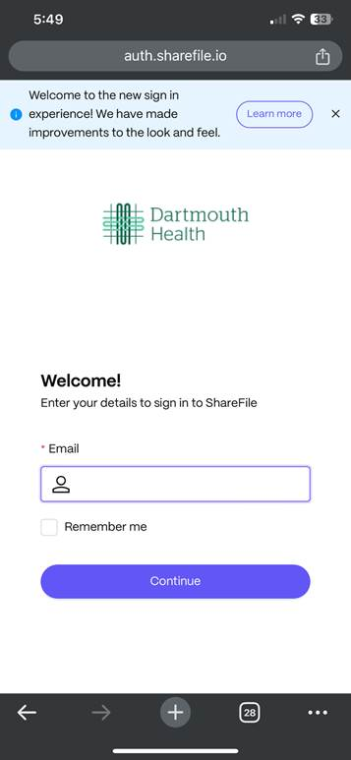
2 - Now input your user’s email. Now select sign-in with company credentials, and input any user credentials.
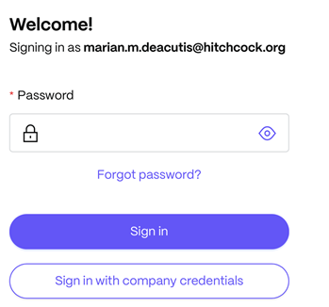

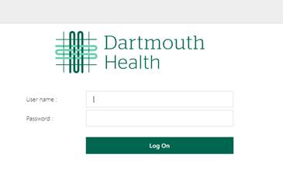
3A- create a folder for these files to be uploaded to

Navigate to folder you created where you wish to place the documents or photos you are going to upload
Tap on the + sign and select upload, select photos or documents to upload, then hit upload, files will be uploaded into folder you have navigated to

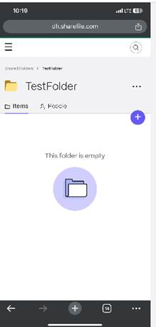

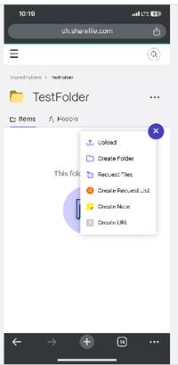

OR
3B - Scroll down to shortcuts and select Shared Folders
Note: After step 3A or 3B, now continue to next step.
4– Now tap on Browse Files and select “From Computer”,
Then select “Photo library” or “choose files” (on phone)

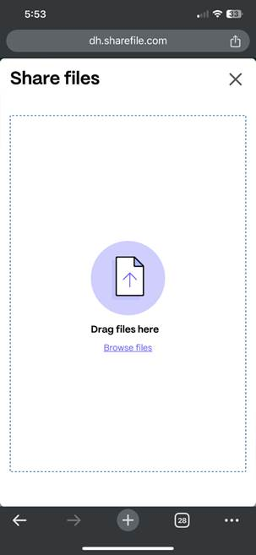
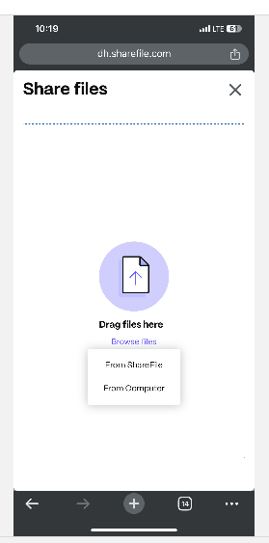
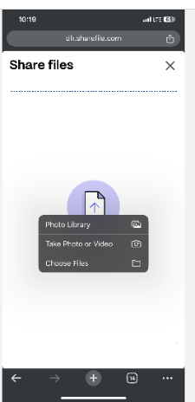

Browse to location on phone where document is located and select the file(s) or photos to upload
If a document / file, click on “open”
If a photo from the photo gallery, click on “add”
File is then uploaded to sharefile into Recent section ( step 3B) or to folder you navigated to in step 3A.

For step 3B: You can create a new folder and move the documents from recent to new folder or an existing folder within sharefile.
Related media
ShareFile url is https://dh.sharefile.com

Escalation questions
Ask user to go to a walkin Help Desk location if needs further assistance than possible over the phone.
Help Desk Analyst should:
- Collect any screenshots/error messages (get the full screen) and add to the ticket.
- Document what steps you did to resolve the issue in the ticket (including the steps you took from this KA).

CI = Citrix Files (ShareFile)
Service Catalog Values = Help Desk > Mobile Device > Submit Request
Escalation Tree:
Tier 1: IS - Support - Help Desk
Tier 2: Windows Administration
Tier 3: N/A
Return to table of Content
-------------------------------------------------------------------------------------------------------------

A11. Access ShareFile from File Explorer
Keywords – Sharefile in File Explorer, File Explorer ShareFile mapping, Windows Desktop app for ShareFile

In order to have your ShareFile (CitrixFiles) folders show in Window File Explorer the Citrix Files application needs to be installed on the computer.

The application can be downloaded from the users ShareFile Web Portal:
dh.sharefile.com

Enter your DH email address and click Continue
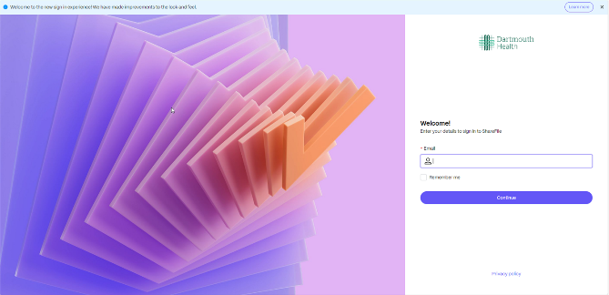

Click on Sign in with my company credentials
DO NOT ENTER A PASSWORD HERE
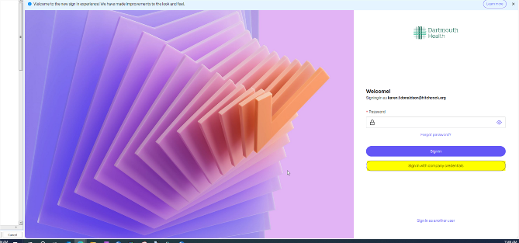

Enter your DH credentials
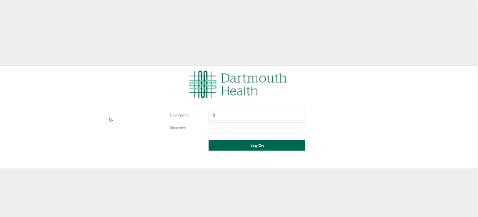

Click on Apps in the top right corner
Then Click Download under ShareFile for Windows
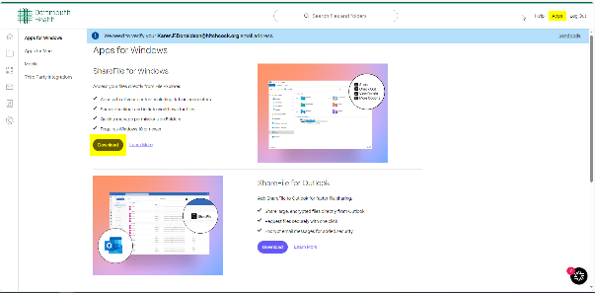

Download and install the Citrix Files for Windows application and restart the computer.
This requires Admin rights. Use your WA credentials to run for the user.

Launch Citrix Files from the desktop:

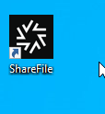

User will need to sign into Sharefile (Citrix Files) as normal, then Citrix Files will appear in Windows Explorer:

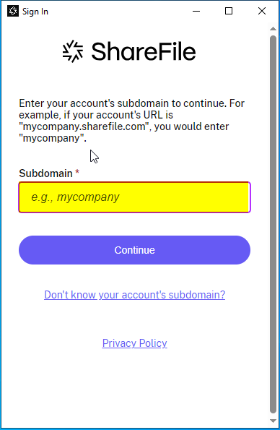

Enter DH in the Subdomain field:

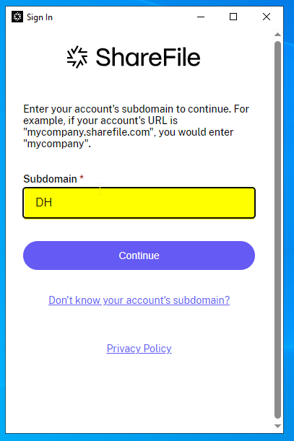

Next Click on Sign in with my company credentials

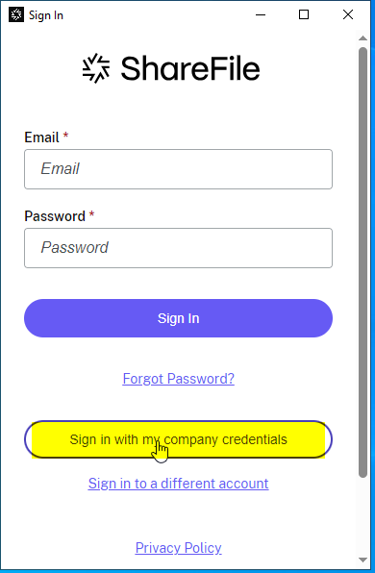

Enter your DH Credentials
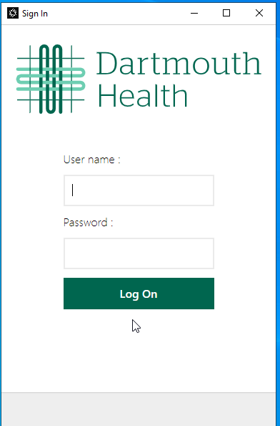

You will see some tutorial screens.
You can Dismiss them or continue and view them

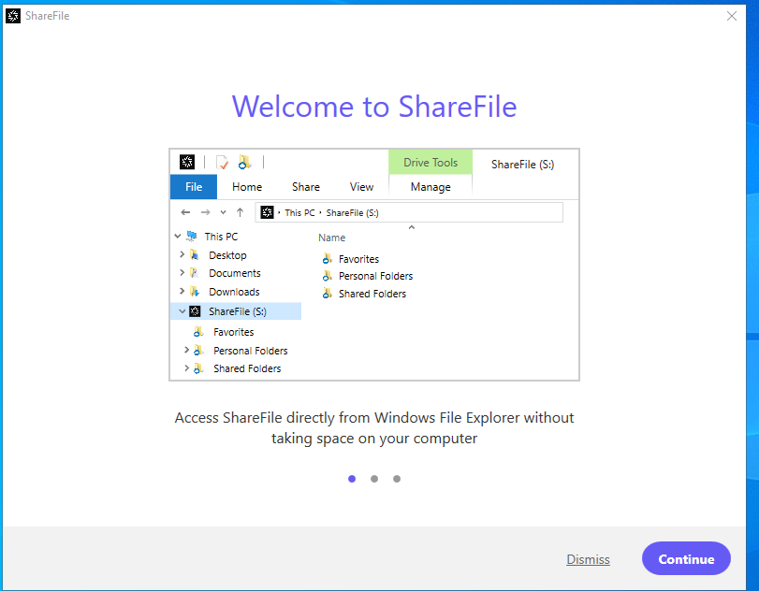

You will then see the ShareFile (S:) in your Windows File Explorer

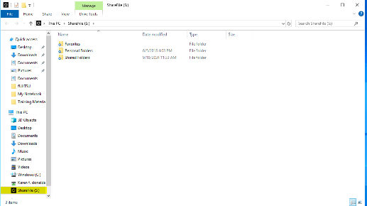

CI = Citrix Files

Service Catalog Values = Help Desk > Software > Submit Request
Escalation Tree:
Tier 1: IS - Support - Help Desk
Tier 2: IS - Support - LEB Software (Or Regional Support)
Tier 3: Windows Administration

Return to table of Content
-------------------------------------------------------------------------------------------------------------

A12. ShareFile Login Error
Keywords – Login Error ShareFile, Login error Citrix files
Issue: User is getting an error when Sharefile tries to load or when opening outlook:

An error has occurred in the script on this page.
'TextDecoder' is undefined

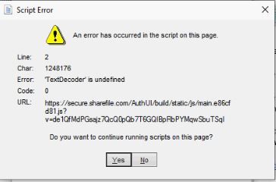

Solution:

Uninstall Citrix Files from the users machine and reinstall from the portal manger

CI = Citrix Files (ShareFile)
Service Catalog Values = Application Support > Issue Resolution > Issue Report
Escalation Tree:
Tier 1: IS - Support - Help Desk
Tier 2: IS - Support - LEB Software (Or Regional Support)
Tier 3: N/A

Return to table of Content

-------------------------------------------------------------------------------------------------------------

A13. How to manage people in ShareFile
Keywords – ShareFile Manage people, Managing outside people in ShareFile, Invitation sent in ShareFile, Invitation
This method can be used for any external ShareFile access.

How to send an invitation to an Outside vendor for ShareFile Access:
https://cms-intranet.hitchcock.org/intranet/departments/help-desk-user-support/services-provided/sharefile/sharefile-managing-people
Manage people
Add, remove, and edit information about people that have permission to access your Sharefile folders.
1. Open the D-HH Sharefile site. https://dh.sharefile.com
2. Under Company Employee Sign In, click Sign In.
3. At User Name, enter your D-HH computer sign in name (typically First M. Last, with spaces).
4. At Password, enter you D-HH computer sign in password.
5. Click Log on.
6. Your personalized dashboard appears in the browser.
7. In the left navigation bar, click People (Figure 1).
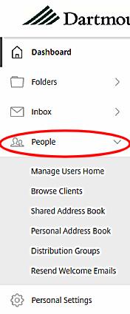
Manager Users Home: search, edit, and create new users in your personal address book
- Browse Clients: search or scroll through a list of entries in your personal address book. Edit entries as needed.
- Shared Address Book: search or scroll through the D-HH Global Address Book.
- Personal Address Book: search or scroll through an address book built on people with permissions in your folders. Select individual entries to edit.
- Distribution Groups: search or scroll through an address book of distribution lists. Manage and edit lists where you are the Group Owner
- Resend Welcome Emails: send a customized message to let the new users knows they've been added to the account and have access to your Sharefile folder(s).
CI: ShareFile
Service Catalog Values = Application Support>How do I> General Request
Escalation Tree:
Tier 1: IS - Support _ Help Desk
Tier 2: N/A
Tier 3: N/A

Return to table of Content

-------------------------------------------------------------------------------------------------------------

A14. ShareFile gives an "edit access error" when creating file links
Keywords – Error accessing, ShareFile edit access error, error when creating file,
Sharefile gives an error when creating file links for an email to another user.

Error is “ Edit access right is not available for shares in Customer Managed Storage Zones”.

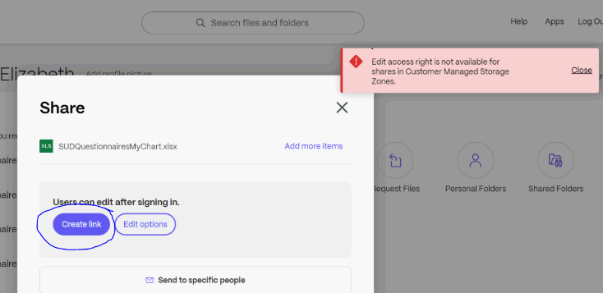

In this case user is trying to create a link while in sharefile that will be put in an email being sent to another user.
Solution:
Have User check in Outlook that he/she is logged into Citrix Files / Sharefile.
User needs to be logged in so the two applications can communicate.

Refer to KA for how to log in

Note: subdomain is “dh” and remember to sign in "using company credentials".

Refer to Installing citrix Files (Sharefile)

CI = Sharefile

Service Catalog Values = Application Support > How Do I? > General Request
Escalation Tree:
Tier 1: IS - Support - Help Desk
Tier 2: IS - Support - LEB Software (Or Regional Support)
Tier 3: Windows Administration

Return to table of Content
-------------------------------------------------------------------------------------------------------------

A15. ShareFile connecting to I: Drive
Keywords – ShareFile I drive, no I drive in Sharefile
Short answer: No
The use case would be Geisel student needing to exchange data associated with an internship in a department from their personal machine. Since this is their personal machine, they can’t download a file from a departmental drive. ShareFile allows them to download the file, manipulate it with their local copy of Microsoft Office, and then upload the file to the departmental drive. This example would apply to any organization not covered by our Microsoft Office license.
What isn’t ideal with this solution is that users would be configure in ShareFile on a case-by-case basis. We can’t map a departmental drive for everyone across the enterprise because Microsoft hasn’t provided a mechanism to support the concept of departmental drives. There is no variable we can use to represent a departmental drive that is equivalent %homeshare% which is used for the H drive. There is also the issue that every department has a different departmental drive. While this solution is labor intensive, it does provide a secure solution.
Return to table of Content
___________________________________________________________________________________________

